ITM Skills University – B.Tech
DBMS Assignment 2
Database Keys: Primary, Foreign and Candidate Keys
Real-World Receipt Analysis

Student Name | Sasanka Sekhar Kundu
Subject | DBMS Fundamentals
Database | PostgreSQL – dbms_assignment_2

1. Receipt Used for Analysis
For this assignment, a supermarket purchase scenario was analysed. The receipt contains store information, bill information, purchased items, quantities, prices, GST, grand total and payment mode.
FRESH MART SUPERMARKET
Kolkata, West Bengal - 700001
GSTIN: 19ABCDE1234F1Z5
Bill No: FM20260823001
Date: 23-08-2026
Time: 01:30 PM
Payment Mode: UPI
Basmati Rice 1kg Qty: 2 ₹120.00 Total: ₹240.00
Amul Milk 1L Qty: 3 ₹65.00 Total: ₹195.00
Britannia Biscuits Qty: 2 ₹30.00 Total: ₹60.00
Subtotal: ₹495.00
GST: ₹24.75
Grand Total: ₹519.75
Note: The database data used below is consistent with this receipt scenario.

2. Tables and Attributes Identified
Store: store_id, store_name, address, gstin
Receipt: receipt_id, bill_number, store_id, purchase_date, purchase_time, payment_mode, subtotal, gst, grand_total
Receipt Item: receipt_item_id, receipt_id, item_name, quantity, unit_price, total_price

3. Candidate Keys
Table | Candidate Key | Reason
Store | store_id | System-generated value that uniquely identifies each store.
Store | gstin | A GSTIN is unique to a registered business in this database design.
Receipt | receipt_id | System-generated value that uniquely identifies each receipt row.
Receipt | bill_number | Each transaction is assigned a unique bill number.
Receipt Item | receipt_item_id | System-generated value that uniquely identifies each item row.
Receipt Item | receipt_id + item_name | In this sample design, the combination identifies an item entry within a receipt.

4. Primary Keys and Justification
Table | Primary Key | Justification
Store | store_id | Chosen because it is short, stable, system-generated and uniquely identifies every store.
Receipt | receipt_id | Chosen because it is a simple system-generated identifier and does not depend on business data.
Receipt Item | receipt_item_id | Chosen because it uniquely identifies every individual item record and remains simple to reference.

5. Foreign Keys and Relationships
1. receipt.store_id → store.store_id
This foreign key links each receipt to the store where the transaction took place.
2. receipt_item.receipt_id → receipt.receipt_id
This foreign key links every purchased item to its corresponding receipt.
STORE
store_id (PK)
|
v
RECEIPT
receipt_id (PK)
store_id (FK)
|
v
RECEIPT_ITEM
receipt_item_id (PK)
receipt_id (FK)

6. PostgreSQL CREATE TABLE Statements
CREATE TABLE store (
store_id SERIAL PRIMARY KEY,
store_name VARCHAR(100) NOT NULL,
address TEXT NOT NULL,
gstin VARCHAR(20) UNIQUE NOT NULL
);
CREATE TABLE receipt (
receipt_id SERIAL PRIMARY KEY,
bill_number VARCHAR(30) UNIQUE NOT NULL,
store_id INT NOT NULL,
purchase_date DATE NOT NULL,
purchase_time TIME NOT NULL,
payment_mode VARCHAR(30) NOT NULL,
subtotal NUMERIC(10,2) NOT NULL,
gst NUMERIC(10,2) NOT NULL,
grand_total NUMERIC(10,2) NOT NULL,
CONSTRAINT fk_store
FOREIGN KEY (store_id)
REFERENCES store(store_id)
);
CREATE TABLE receipt_item (
receipt_item_id SERIAL PRIMARY KEY,
receipt_id INT NOT NULL,
item_name VARCHAR(100) NOT NULL,
quantity INT NOT NULL,
unit_price NUMERIC(10,2) NOT NULL,
total_price NUMERIC(10,2) NOT NULL,
CONSTRAINT fk_receipt
FOREIGN KEY (receipt_id)
REFERENCES receipt(receipt_id)
);
SCREENSHOT 1 – CREATE TABLE SUCCESS

7. PostgreSQL INSERT Statements
INSERT INTO store (store_name, address, gstin)
VALUES (
'Fresh Mart Supermarket',
'Kolkata, West Bengal - 700001',
'19ABCDE1234F1Z5'
);
INSERT INTO receipt (
bill_number, store_id, purchase_date, purchase_time,
payment_mode, subtotal, gst, grand_total
)
VALUES (
'FM20260823001', 1, '2026-08-23', '13:30:00',
'UPI', 495.00, 24.75, 519.75
);
INSERT INTO receipt_item (
receipt_id, item_name, quantity, unit_price, total_price
)
VALUES
(1, 'Basmati Rice 1kg', 2, 120.00, 240.00),
(1, 'Amul Milk 1L', 3, 65.00, 195.00),
(1, 'Britannia Biscuits', 2, 30.00, 60.00);
SCREENSHOT 2 – INSERT SUCCESS

8. Verification Using SELECT Statements
SELECT * FROM store;
SELECT * FROM receipt;
SELECT * FROM receipt_item;
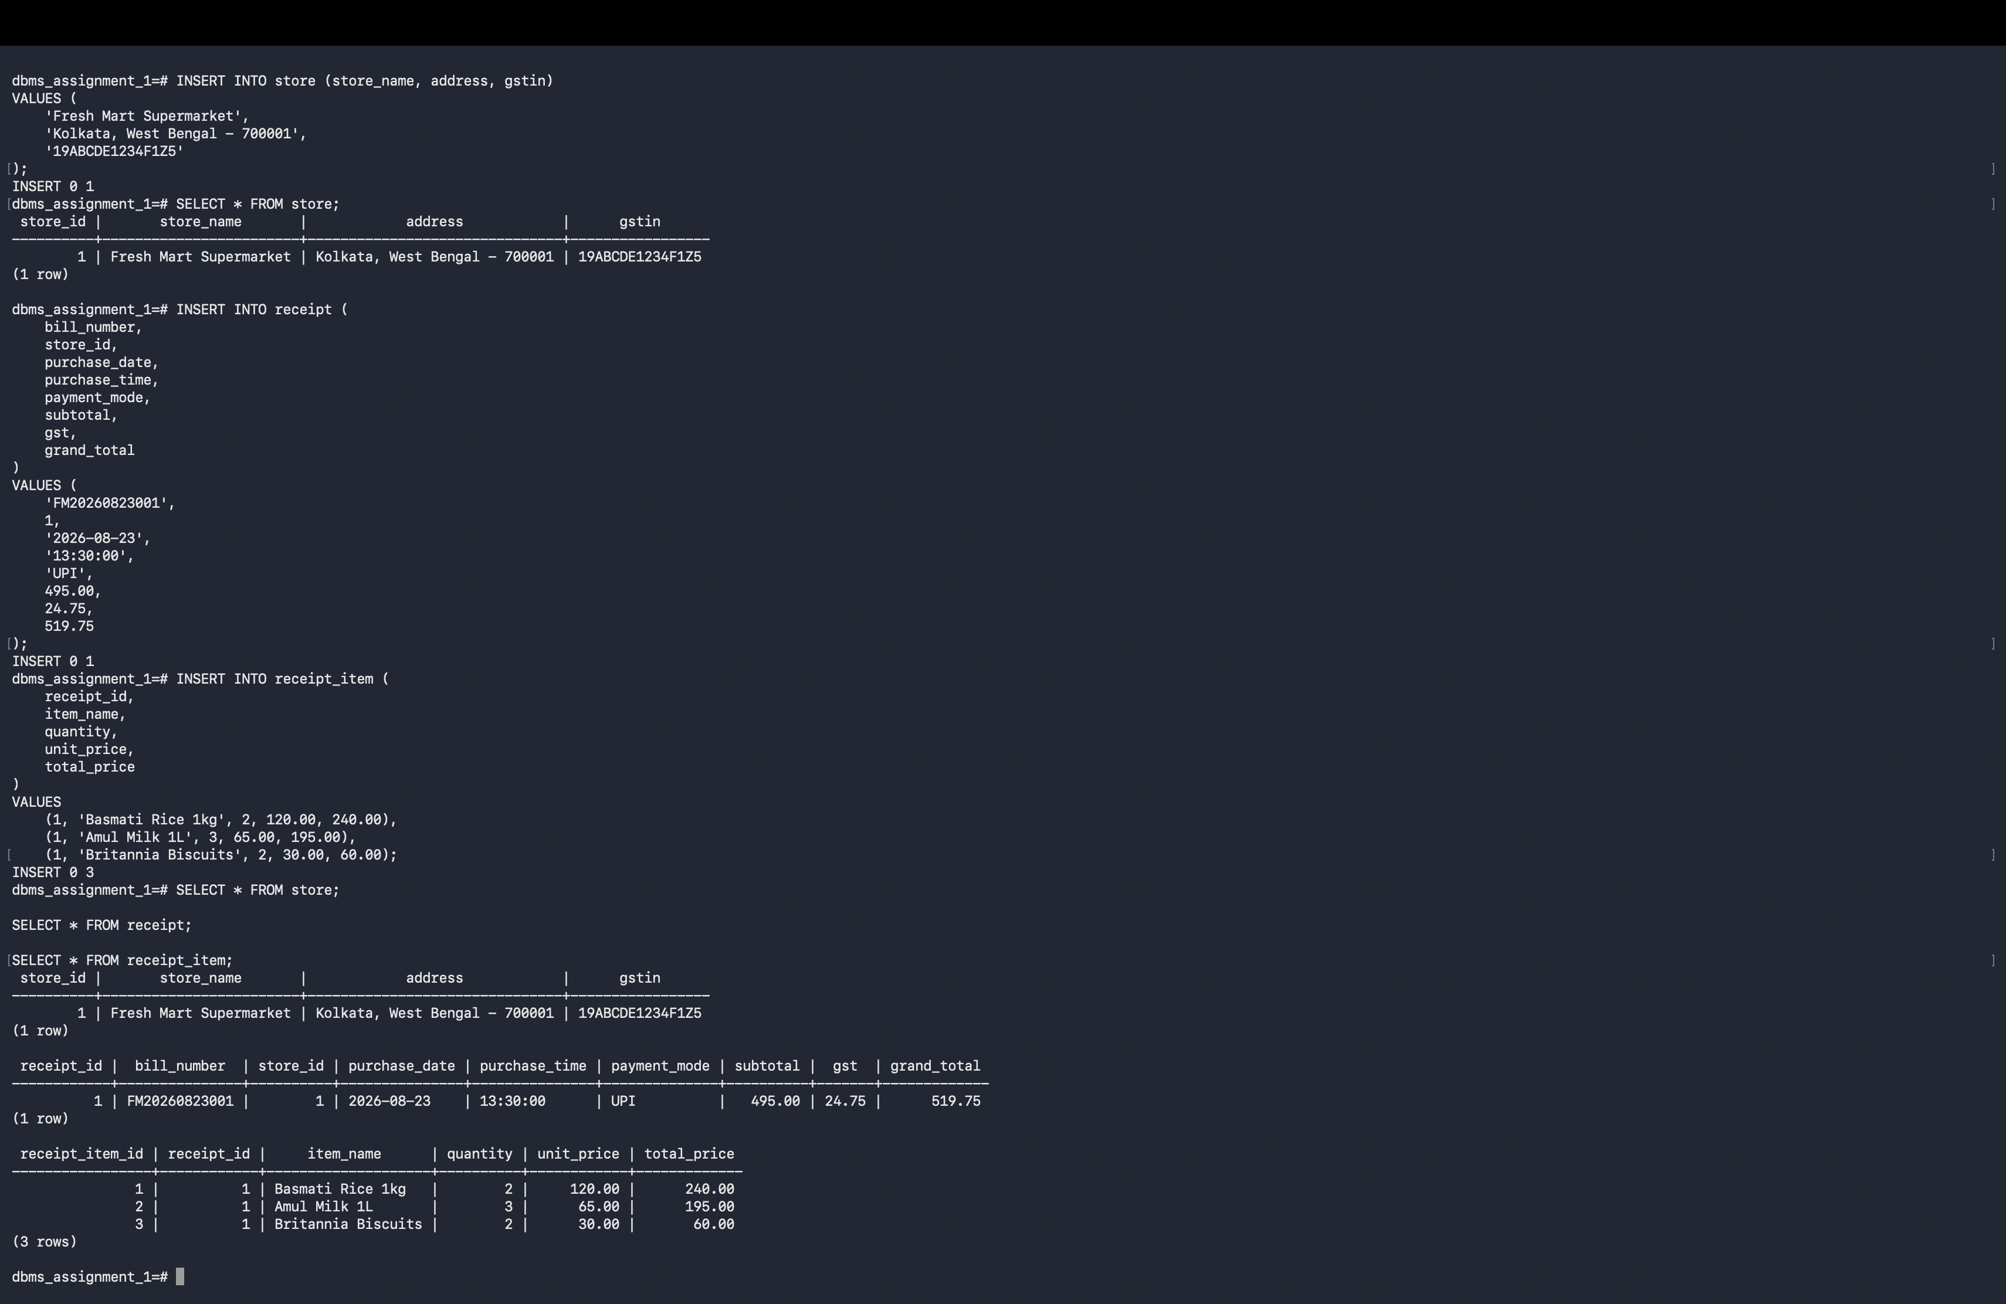SCREENSHOT 3 – SELECT RESULTS

9. Summary
This assignment analyses a supermarket receipt and converts its information into a relational database design. The receipt data was divided into three logical tables: Store, Receipt and Receipt_Item. The Store table keeps information about the supermarket, while the Receipt table stores details of the complete transaction. The Receipt_Item table stores every individual product purchased in that transaction. For the Store table, both store_id and GSTIN can uniquely identify a store, so they are candidate keys. store_id was selected as the primary key because it is short, system-generated and stable. In the Receipt table, receipt_id and bill_number are candidate keys. receipt_id was selected as the primary key for the same reason. In the Receipt_Item table, receipt_item_id uniquely identifies each item row and was selected as the primary key. The store_id column in Receipt is a foreign key referencing Store, which links every bill to its store. Similarly, receipt_id in Receipt_Item is a foreign key referencing Receipt, linking each purchased item to the correct transaction. These keys reduce duplication and maintain proper relationships and data integrity in the PostgreSQL database.

10. Conclusion
The PostgreSQL statements were successfully executed in the dbms_assignment_1 database. The three tables were created, the receipt data was inserted, and the stored records were verified using SELECT queries.

